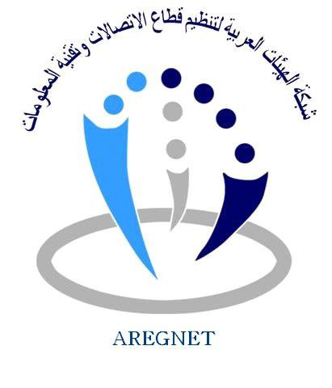

ITU & AREGNET workshop on the OTT services
Draft Agenda

(27 April 2015 )
08:00- 09:00 | Registration
09:00- 09:30 | Opening Session
09:30- 10:00 | Arab OTT team Report
10:00- 11:00 | Session 1 ITU Expert  Introduction on NGN driving services and OTTs  - IP based services VS Conventional services  - Impact of OTT on services
11:00- 11:30 | Coffee break
11:30- 12:30 | Session 2 ITU Expert  - Relationship between TELCOS and OTTs  - The value chain and services migration flow
12:30- 13:30 | Lunch Break
13:30- 14:30 | Session 3 ITU Expert  - Regulatory initiatives regarding OTT services
14:30- 15:30 | Session 4 ITU Expert  - Regulations for the provision of service: market players perspective
15:30- 16:30 | Session 5  - Discussions and closing

